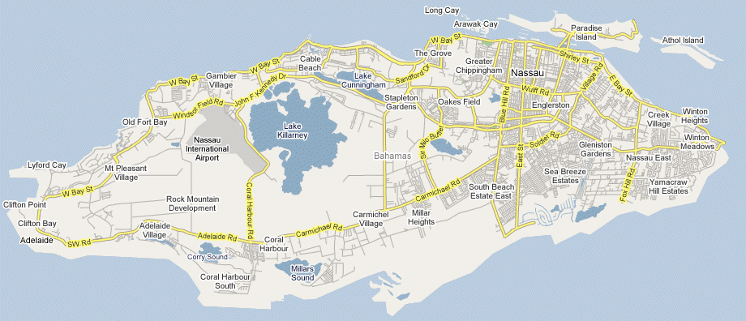

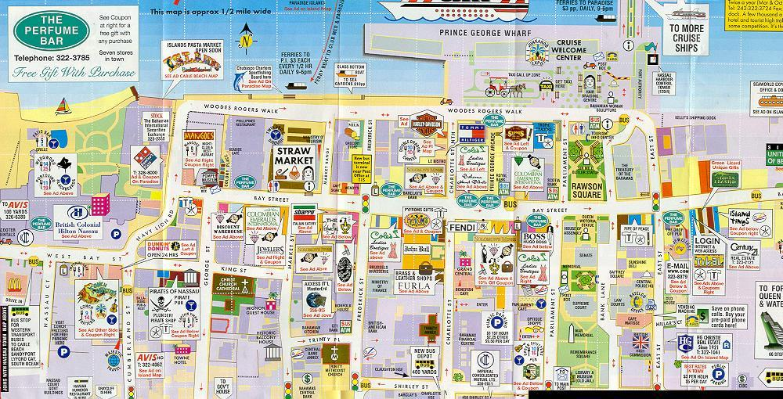

- Atlantis
- Government House
- Rawson Square
- Straw Market
- Blackbeard’s Tower
- El GRECO
- Cable Beach
- Queens Staircase

- Water Tower
- Pompey Museum-
- British Colonial Hotel and Bus Stop
- Nassau Botanic Garden
- Pirates Museum
- Arawak Cay
- Christ Church Cathedral

- Fort Fincastle
- Fort Charlotte
- Balcony House and Trinity Place
- Eastern cemetery
- Potters cay
- Columbus Tavern
- Cafe matisse

- The Shoal Restaurant and Lounge
- The Retreat
- Fort Montagu
- The Caves

