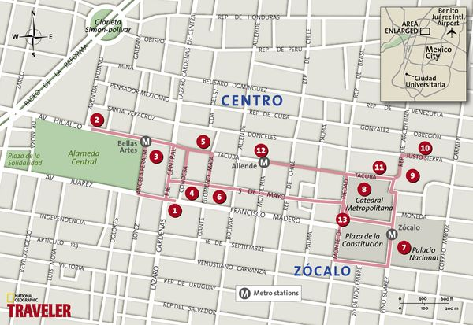
The ten-acre (four-hectare) Historic Center of Mexico City is home to numerous museums and has benefited in recent years from a committed preservation push.
If you have managed an early start and it is a clear day, begin at the (1) Torre Latinoamericana (Eje Central and Avenida Madero, open from 9 a.m.). For a small fee you catch an elevator to the top and will have a breathtaking view of the city’s heart, as well as two snowcapped volcanoes to the east.
Take a left on Avenida Juárez toward the Alameda Park. On diametrically opposite sides lie a brand new sculpture garden, or the fine (2) Franz Mayer Museum (Avenida Hidalgo 45; www.franzmayer.org.mx) in a restored convent. Depending upon whether your curiosity leads you to modernity or history, choose one and follow up by crossing through the park to enter the elegant white marble (3) Palace of Fine Arts (Palacio de Bellas Artes, Avenida Hidalgo 1; www.bellasartes.gob.mx).
Former President Porfirio Diaz commissioned the concert hall and museum in 1904 and hired the Italian architect Adamo Boari, who also built the stunning National Post Office (Correo Mayor) building across the street. Of the murals within, don’t forget to catch Diego Rivera’s “Man, the Controller of the Universe,” on the third floor. The Rockefeller family first commissioned it for the center in New York City, but then took offense at the work’s anti-capitalist themes and had it destroyed, so the Mexican artist reproduced it in more detail here.
Cross back over the Eje, turning left (north) to enter the Post Office, decorated on the exterior with gargoyles and elaborate stone carving. Double back to the department store Sanborns, housed in the historic (4) Casa de los Azulejos (Madero and Callejon de la Condesa) for coffee and an authentic Mexican breakfast of huevos rancheros. Next, head toward the Zócalo along Tacuba Street to the adjacent Palace of Mining (Palacio de Mineria), considered one of Mexico’s finest examples of neoclassical architecture. The building, completed in 1813, is one of the leading works by Manuel Tolsa who also designed the (5) National Art Museum (MUNAL, Tacuba 8), opposite, which you can explore to your heart’s content but don’t forget to spend some time in the rooms exhibiting 20th-century Mexican art, past the far courtyard.
Next cut over to the Cinco de Mayo Avenue, named for the Mexican army’s brief defeat of Napoleon’s troops in 1862. Here you will find the (6) Bar La Opera (Cinco de Mayo 10, Col. Centro) for a shot of tequila.
Replenished, head east to the Zócalo (Plaza de la Constitución), where you are spoiled for choice—will it be Rivera’s murals and a stroll around the inner courtyard in the (7) National Palace? Or a tour of the grand (8) Metropolitan Cathedral, built over centuries and finally finished in 1813, which melds three centuries of Mexican architectural styles? But you cannot miss the adjacent (9) Templo Mayor Museum (Seminario 8), or—if you are in the mood for art—walk two blocks to the excellent (10) San Ildefonso Museum (Justo Sierra 16).
A late lunch is recommended either in the (11) Centro Cultural de España (Guatemala 18) behind the cathedral or (12) Café Tacuba (Tacuba 28), back on Tacuba street, completed by a final relaxing bus ride on the (13) Turibus (www.turibus.com.mx), which leaves from the northwest corner of the Zócalo.

